ECONOMICS YEAR 12

SEMESTER ONE EXAMINATION 2000

INSTRUCTIONS TO CANDIDATES:

TIME ALLOWED: Reading 10 Minutes
Working of Paper 3 Hours

This paper is divided into THREE (3) sections:

PART A Multiplechoice: Answer all questions on the sheet provided Use a 2B, B or
HB pencil, on the separate Multiple Choice Answer sheet provided in the separate Answer Booklet. Do NOT use a ball point or ink pen.

PART A Worth 25 Marks

PART B Data Interpretation: Answer all questions in the spaces provided

PART B Worth 30 Marks

PART C Essay: Attempt 3 of the 5 questions. Write your answers on the
lined paper provided in the separate Answer Booklet.

PART C Worth 45 Marks

Additional answering space for Section B and Section C is available at the end of this booklet.

STRUCTURE OF THIS PAPER

Section | Format | No. of questions available | No. of questions to be attempted | Suggested time/minutes | Marks
A | Multiple Choice | 25 | ALL | 30 | 25
B | Data Interpretation | 3 | ALL | 60 | 30
C | Extended Writing | 5 | 3 | 90 | 45
Total Marks = 100
SECTION A – Multiple Choice Questions (25 Marks)

Suggested time – 30 minutes

Attempt all questions from this section. Choose the alternative which correctly answers the question or completes the statement. Record your answers on the separate Multiple Choice Answer Sheet using a 2B, B or HB pencil. Read the instructions on this sheet with care.

Each question is worth 1 mark.

___________________________________________________________________________________

- Which of the following items would NOT be included when calculating Australia’s GDP?

- The winnings of a golf professional
- A bunch of flowers sold by a florist
- Furniture sold by retailers
- Timber sold to furniture manufacturers.

- If planned investment exceeded planned savings

- the level of business confidence must have fallen
- inventories (stocks) will increase
- inventories (stocks) will decrease
- actual savings will rise immediately to the same level.

- Consumers initially spent 70 per cent of any increase in income. If this proportion was raised to 75 per cent, then

- the size of the multiplier coefficient would rise
- the size of the multiplier coefficient would fall
- there would be no change in the size of the multiplier coefficient
- the size of the multiplier coefficient would initially rise, then return to its original value.

- Using total expenditures approach, GDP may be calculated as

- GDP = C + I + G + (exports – imports).
- GDP = C + I + G + (exports + imports)
- GDP = C + I + (G – X)
- GDP = C + (I-G) + (exports – imports)

- The natural rate of unemployment in an economy is

- a zero unemployment rate
- whatever rate the economy is experiencing at the present time
- the rate which fluctuates with the level of aggregate demand
- the lowest sustainable rate of unemployment.

- The following diagram refers to an economy which has no government or overseas sectors. The current level of income is OY₁, which is less than the full employment level at OY_{f}

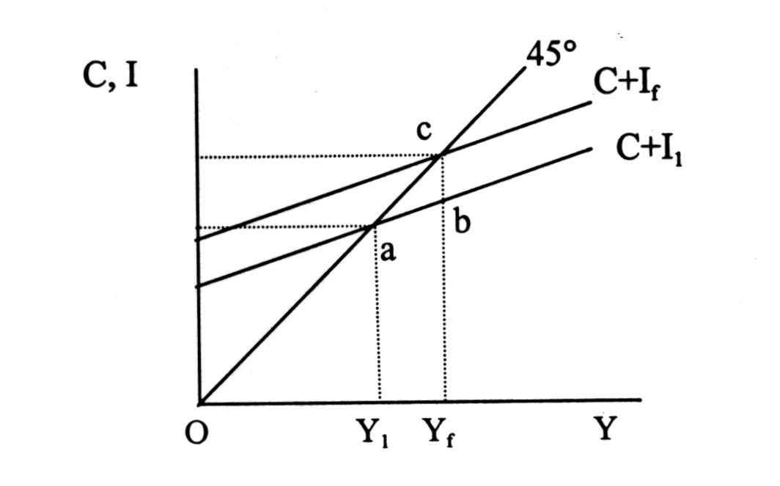
To achieve full employment, by how much must the level of consumption and investment expenditure rise?

- bc
- ab
- ac
- Less than bc, due to the existence of the multiplier.

- A country has an absolute advantage in the production of a good if

- the opportunity cost of producing the good is less than in another country
- it can produce the good with less resources than another country
- the money cost of producing the good is lower than in another country
- none of the above

- To suggest that Australia has a comparative advantage in the production of wheat means that:

- Australia can produce wheat with fewer resources than another country
- Australia is a more efficient producer of wheat compared to other countries
- The opportunity cost of producing wheat in Australia is greater than in other countries
- The opportunity cost of producing wheat in Australia is less than that of other countries

- Consider the following tax schedule

Income  Tax | ($)  ($) | 200  30 | 300  70 | 400  120 | 500  180

This schedule is an example of

- progressive tax
- proportional tax
- indirect tax
- regressive tax

- The “terms of trade” between two countries is the

- period allowed for settling foreign trade contracts.
- price index of exports relative to the price index of imports
- difference in the opportunity cost of producing the same good in each country
- Interest charged on loans used to finance foreign debt.
- Which of the following is NOT likely to be a cause of cost-push inflation?

- The award of higher wages to all workers
- Increased prices for Australian exports
- Increased consumer spending
- Increased prices for imports

- When all resources are fully employed in an economy, any increase in spending will result in

- demand-pull inflation
- a decrease in total employment
- a reduction in aggregate supply
- none of the above

- The most volatile or unstable component of aggregate demand is

- a private consumption spending
- private investment expenditure
- government expenditure on capital goods
- expenditure on imports

- Which of the following workers is most likely to be classified as structurally unemployed?

- a car factory worker who loses his job because of a government policy to reduce the number of car manufacturers
- a recent university graduate seeking her first job
- a woman who has decided to return to work after her children start school but who has been unable to find a job
- a factory worker who has lost his job because of a fall in economic activity

- Which of the following statements is true?

- the Phillips curve shows an inverse relationship between inflation and unemployment
- stagflation has caused some economists to believe that the Phillips curve has moved to the left
- the Phillips curve shows that at low levels of unemployment any further reduction in unemployment would have a minimal impact on inflation
- none of the above

16.

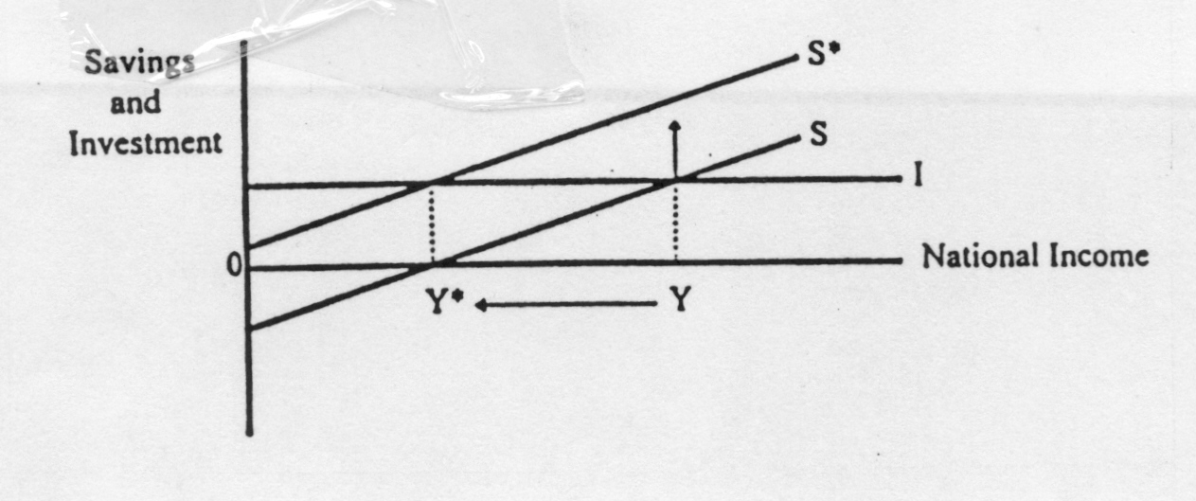
The diagram above best illustrates the

- fallacy of composition
- paradox of thrift
- ratchet effect
- induced savings

17. The underlying rate of inflation includes

- price volatile items
- prices of items significantly affected by seasonal changes
- prices of items affected by government policy decisions
- all of the above.

- The diagram below shows the production possibility curves for computers and clothing in Japan and Malaysia

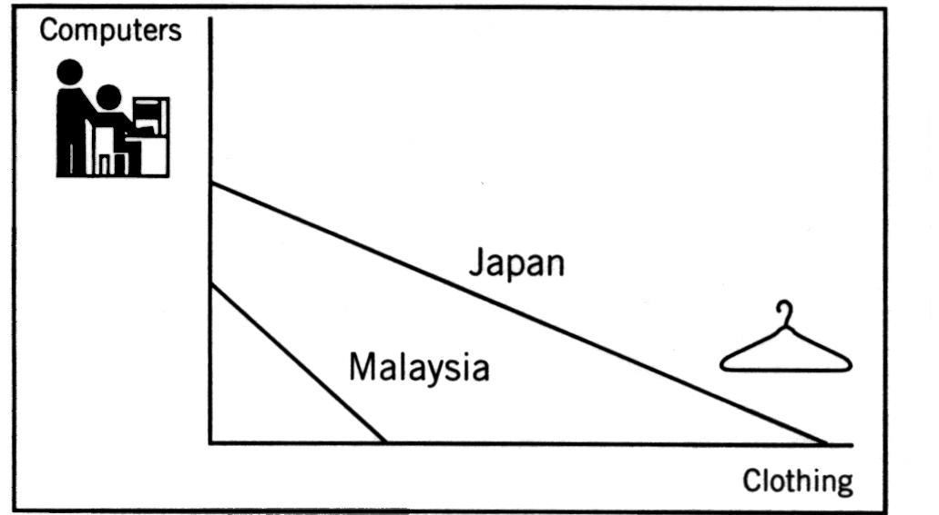

From this diagram it can be concluded that:

- Japan has an absolute advantage in the production of both products
- The opportunity cost of producing clothing in Japan is less than in Malaysia
- Malaysia has a comparative advantage in producing clothing
- Malaysia cannot gain by trading with Japan

- Economic growth tends to result in

- a favourable balance of trade for the country
- expansion of employment in every sector of the economy
- an increasing ability of the country to become internationally independent
- an increasing ability of the country to satisfy it wants

- In the short time reduction in tariffs are likely to

- raise the rate of inflation
- raise the rate of unemployment in industries previously protected by the tariffs
- lead to a deficit on the capital account of the balance of payments
- make domestic producers take steps to become more efficient

- The principle of comparative costs, or the law of comparative advantage is

- factor costs
- opportunity costs
- money costs
- exchange rates

- International trade in goods might eventually cease if

- transport costs were negligible
- trade in primary products ceased
- exchange rates are allowed to float freely
- factors or production were all perfectly mobile

- The following data refers to the data refers t the production possibility curves in two countries (A and B) when they make two products (F and G).

Country A
Units of Good F  Units of Good G | 0  0 | 4  2 | 8  4 | 12  6 | 16  8

Country B
Units of Good F  Units of Good G | 8  20 | 6  15 | 4  10 | 2  5 | 0  0

The law of comparative advantage suggests:

- neither country can gain from international trade
- country A has a comparative advantage in both products
- country A should make F and country B, G
- country A should make G and country B, F

- Economic growth normally causes:

- an increase in material living standards for all households in an economy
- greater price stability
- increased profits for some sectors of the economy
- reduced taxation revenue for the government to spend on welfare and environmental programs.

- Economic growth is most likely to cause:

- structural unemployment
- demand deficiency unemployment
- youth unemployment
- seasonal unemployment
SECTION B – Data Interpretation (30 Marks)

Suggested time – 60 minutes

Answer ALL THREE (3) questions. Each question is worth 10 marks. Write your answers in the spaces provided under each part question.

___________________________________________________________________________________

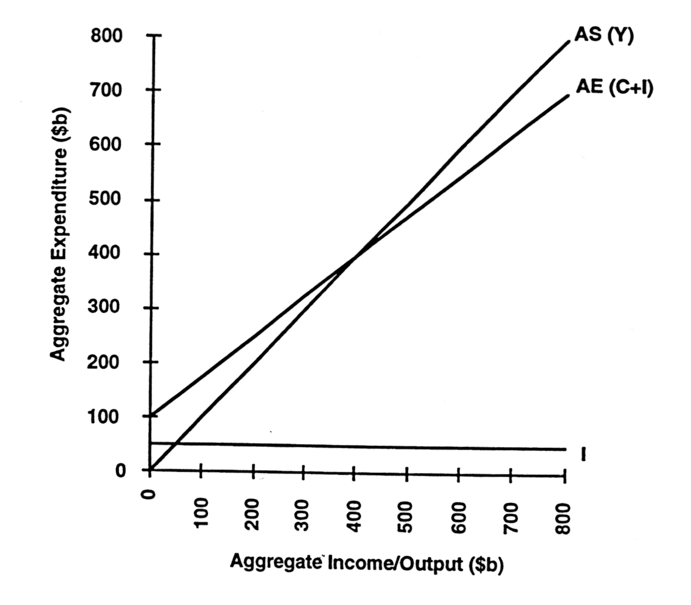

26. (a) Is the diagram above showing autonomous or induced investment?

_______________________________________________________________________
(1 mark)

- show the equilibrium level of income for the three sector model by drawing a line from the equilibrium point to aggregate income and calling it Ye1.
(1 mark)

- Draw in an increase in autonomous investment of $100 billion on the diagram. Call the new investment line I2 and the new aggregate expenditure line AE2.
(1 mark)

- Show the new level of equilibrium income. Call it YE2.
(1 mark)

- What is the effect of the upwards movement of AE on income, output and employment? Give specific figures.
(6 marks)

_______________________________________________________________________
_______________________________________________________________________
_______________________________________________________________________
_______________________________________________________________________
_______________________________________________________________________
_______________________________________________________________________
_______________________________________________________________________
_______________________________________________________________________
_______________________________________________________________________
_______________________________________________________________________
_______________________________________________________________________
_______________________________________________________________________
_______________________________________________________________________
_______________________________________________________________________

27. Read the following table, which refers to economic indicators for Country W. You may assume that County W has similar economic institutions to Australia.

Year | Nominal rate of interest (average of consumer and business loans) | Exchange rate (domestic currency in terms of $US) | Rate of inflation (%p.a. change in CPI) | Economic growth (% change in GDP at constant prices)
1 | 9.0 | 0.85 | 7.0 | 4.9
2 | 8.2 | 0.79 | 6.1 | 4.0
3 | 7.4 | 0.78 | 5.2 | 3.3
4 | 6.8 | 0.82 | 3.2 | 2.7

- Which of the years shown has the highest real rate of interest?

Year________________ Real rate of interest_________________% (2marks)

- Explain why the real rate of interest is more important than the nominal rate of interest to both borrowers and lenders. (3 marks)

_______________________________________________________________________
_______________________________________________________________________
_______________________________________________________________________
_______________________________________________________________________
_______________________________________________________________________
_______________________________________________________________________
_______________________________________________________________________
_______________________________________________________________________

- Discuss the relationships between inflation, productivity and real wages with reference to the information in the table. (5 marks)

_______________________________________________________________________
_______________________________________________________________________
_______________________________________________________________________
_______________________________________________________________________
_______________________________________________________________________
_______________________________________________________________________
_______________________________________________________________________
_______________________________________________________________________
_______________________________________________________________________
_______________________________________________________________________
_______________________________________________________________________
_______________________________________________________________________

28. The following chart is based on data supplied by the Reserve Bank of Australia. Examine the chart and answer the questions below.

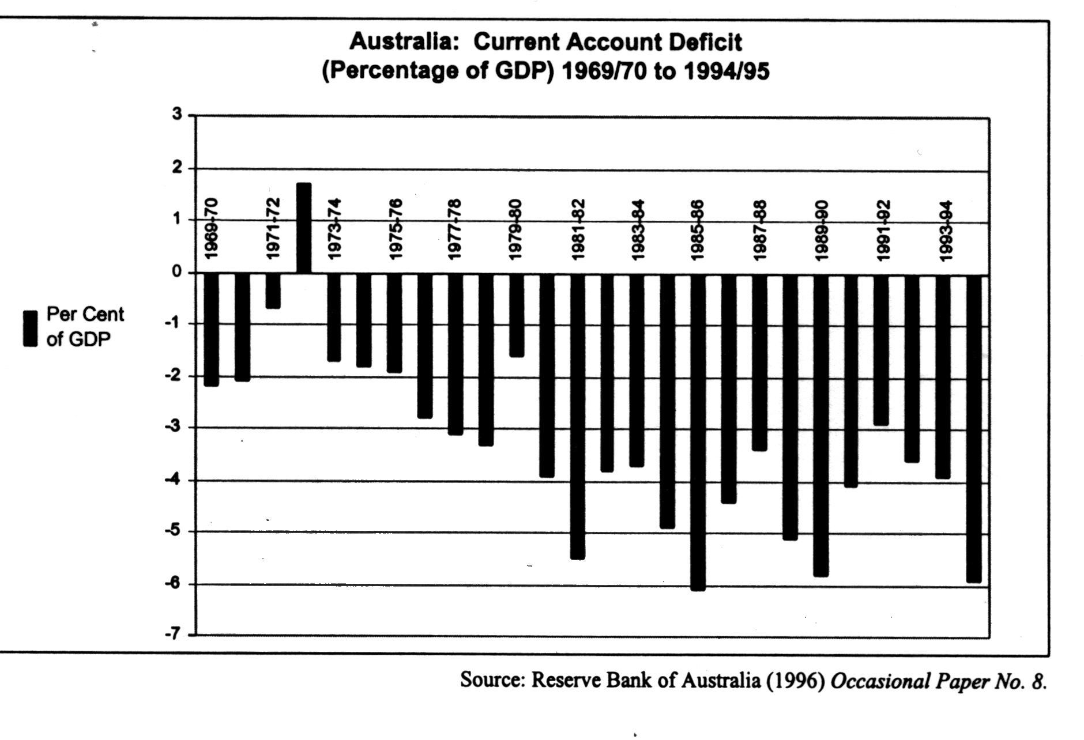
- Define the term “current account deficit” (CAD)

_______________________________________________________________________
_______________________________________________________________________
_______________________________________________________________________
_______________________________________________________________________
_______________________________________________________________________
________________________________________________________________(2 marks)
- List three reasons why the CAD as a percentage of GDP has risen during the last four time periods shown on the chart.

_______________________________________________________________________
_______________________________________________________________________
_______________________________________________________________________
_______________________________________________________________________
_______________________________________________________________________
________________________________________________________________(3 marks)

- What problems may arise for the Australian economy from a persistent deficit on the current account of the balance of payments?

_______________________________________________________________________
_______________________________________________________________________
_______________________________________________________________________
_______________________________________________________________________
_______________________________________________________________________
_______________________________________________________________________
_______________________________________________________________________
_______________________________________________________________________
_______________________________________________________________________
_______________________________________________________________________
_______________________________________________________________________
________________________________________________________________(5 marks)
SECTION C – Essays and Extended Answers (45 marks)

Suggested time – 80 minutes

Answer any THREE (3) questions. Each question is worth 15 marks. Write your answer in the Question/Answer Booklet using the pages which follow the end of Section C. Number your responses clearly.

___________________________________________________________________________________

29. (a) Define “marginal propensity to consume” (MPC). Using a diagram, explain how changes
in the value of the MPC affect the level of consumption spending in the economy.
(5 marks)

- Using the Keynesian cross/aggregate expenditure model, discuss what effects changes in levels of consumption and private investment expenditure have on the equilibrium level of output.
(10 marks)

___________________________________________________________________________________

- Outline how a reduction in the size of a government budget deficit might impact on the macroeconomic objectives of price stability, economic growth and external balance.
(15 marks)

___________________________________________________________________________________

31. (a) Define “inflation” and explain how it is measured.
(5 marks)

- Discuss the factors which have contributed to the low level of inflation in Australia in recent years.
(10 marks)

___________________________________________________________________________________

32. (a) What are the economic benefits of international trade?
(8 marks)

- Describe and account for the changes in the pattern of Australia’s trade over the last three or four decades.
(7 marks)

___________________________________________________________________________________

- Using diagram(s), discuss how monetary policy can be used to influence the level of employment and economic growth.
(15 marks)
Student Name:_______________________________________

Teacher:____________________________________________

WARNBRO COMMUNITY HIGH SCHOOL


ECONOMICS YEAR 12

SEMESTER ONE EXAMINATION 2000

ANSWER BOOKLET

Please indicate the question numbers you have attempted for Section C in the space below.

Section A

Multiple Choice Q1 – 25

Section B

Data Interpretation Q26 – 28

Section C

Q_______

Q_______

Q_______

TOTAL MARKS

Name…………………………………

ANSWER SHEET FOR QUESTIONS 1 TO 30

Question  Number | Answer |  |  |  |  | Question  Number | Answer
1 | A | B | C | D |  | 16 | A | B | C | D
2 | A | B | C | D |  | 17 | A | B | C | D
3 | A | B | C | D |  | 18 | A | B | C | D
4 | A | B | C | D |  | 19 | A | B | C | D
5 | A | B | C | D |  | 20 | A | B | C | D
6 | A | B | C | D |  | 21 | A | B | C | D
7 | A | B | C | D |  | 22 | A | B | C | D
8 | A | B | C | D |  | 23 | A | B | C | D
9 | A | B | C | D |  | 24 | A | B | C | D
10 | A | B | C | D |  | 25 | A | B | C | D
11 | A | B | C | D
12 | A | B | C | D
13 | A | B | C | D
14 | A | B | C | D
15 | A | B | C | D

